***SET UP SVN in Eclipse***

1. *Launch the Eclipse IDE and from Help menu, click “****Eclipse Market****”*

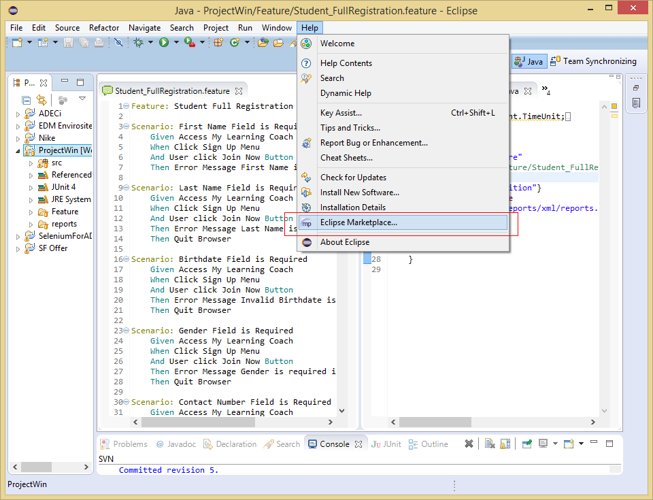

1. *You will see a Eclipse Marketplace window, search for “****Subclipse****”*

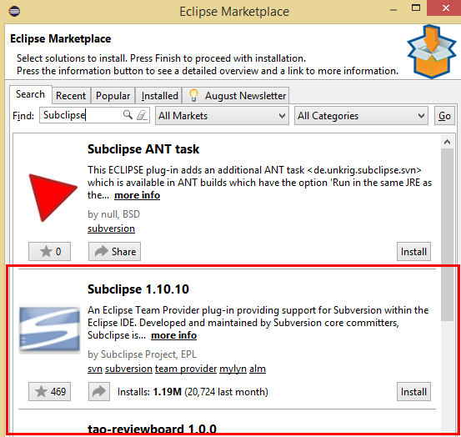

1. *Install* ***Subclipse,*** *then click* ***Confirm Button***

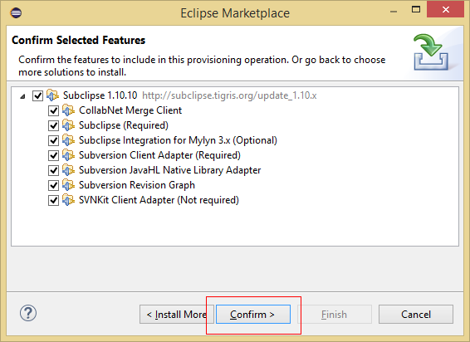

1. *Select “****I accept the terms of the license agreements****”, then click* ***Finish Button***

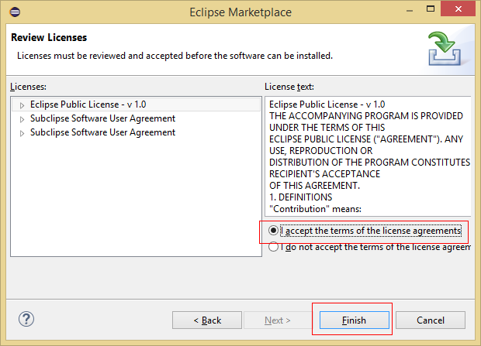

1. *Restart Eclipse*

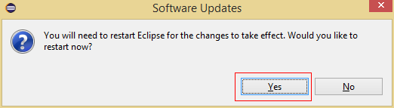

***How to Initial Check-in or Commit***

1. *Right-Clicked Project [****ProjectWin****], hover* ***Team*** *then click* ***Share Project***

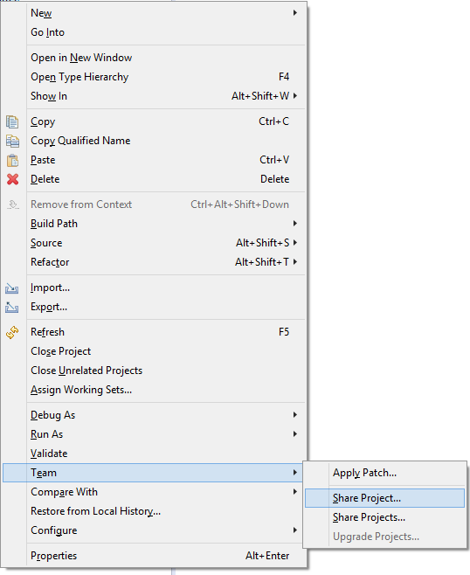

1. *Select* ***SVN****, then click* ***Next Button***

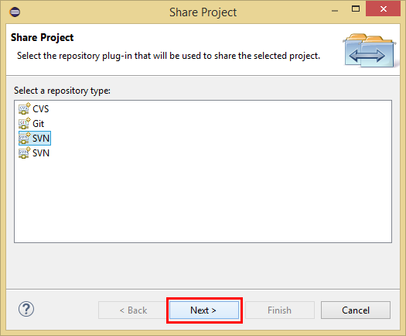

1. *Select “****Create a new repository location****”, then click* ***Next Button***

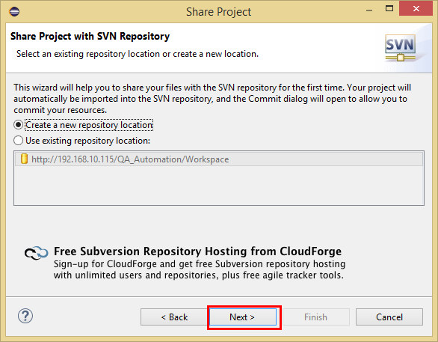

1. *Type* ***SVN Path*** *“****http://192.168.10.115/QA_Automation/Workspace/****”, then click* ***Finish Button***

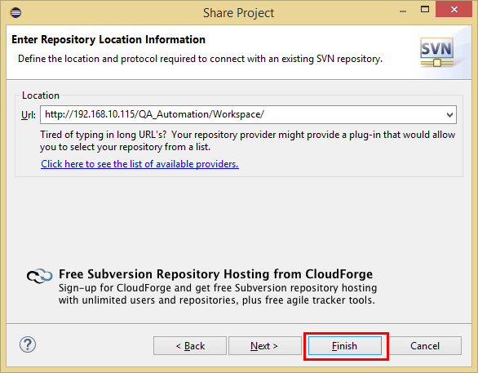

1. *Right-clicked Project [****ProjectWin****], then Commit*

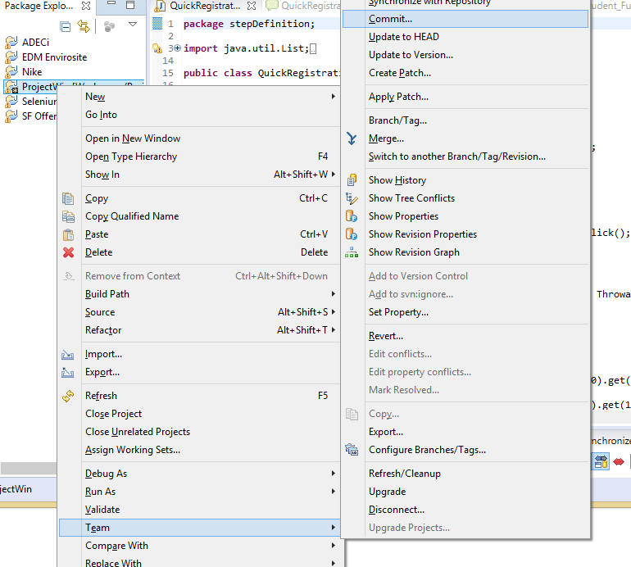

1. *Type* ***Commit Comment****, then click* ***OK Button***

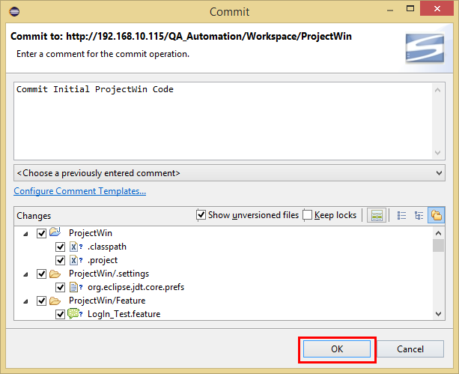

***HOW to Check-out a Project***

1. *Right-clicked workspace, then click* ***Import***

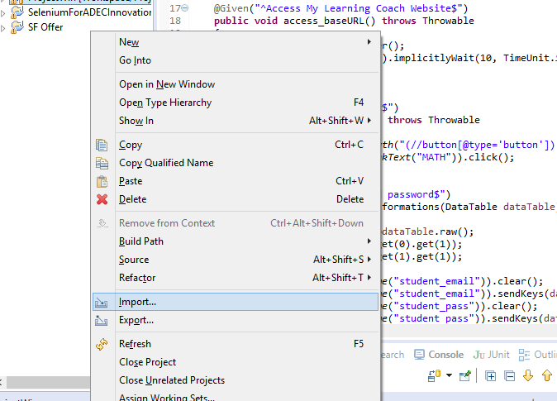

1. *Select “****Checkout Projects from SVN****”, then click* ***Next Button***

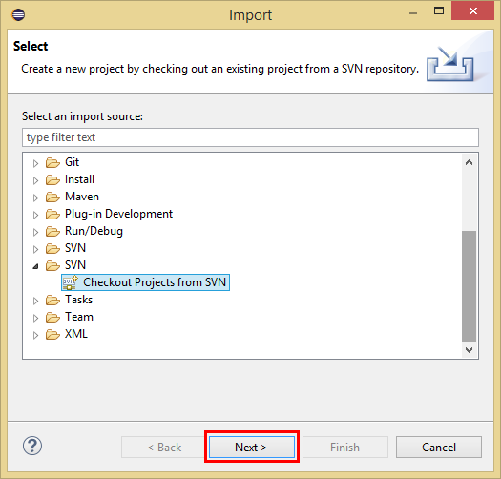

1. *Select existing repository, then click* ***Next Button***

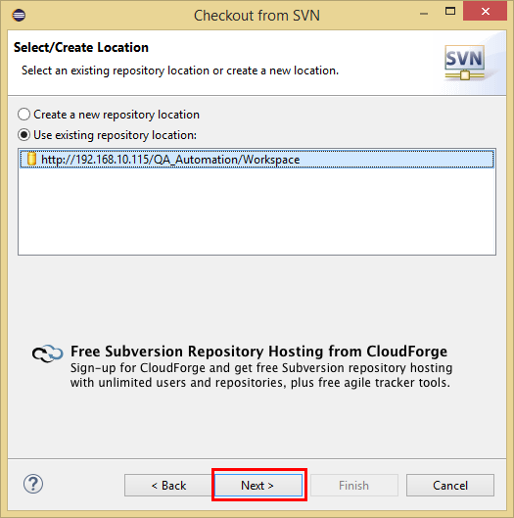

1. *Select* ***Project*** *you want to checkout, then click* ***Finish Button***

